**Wyeside Day Nursery**

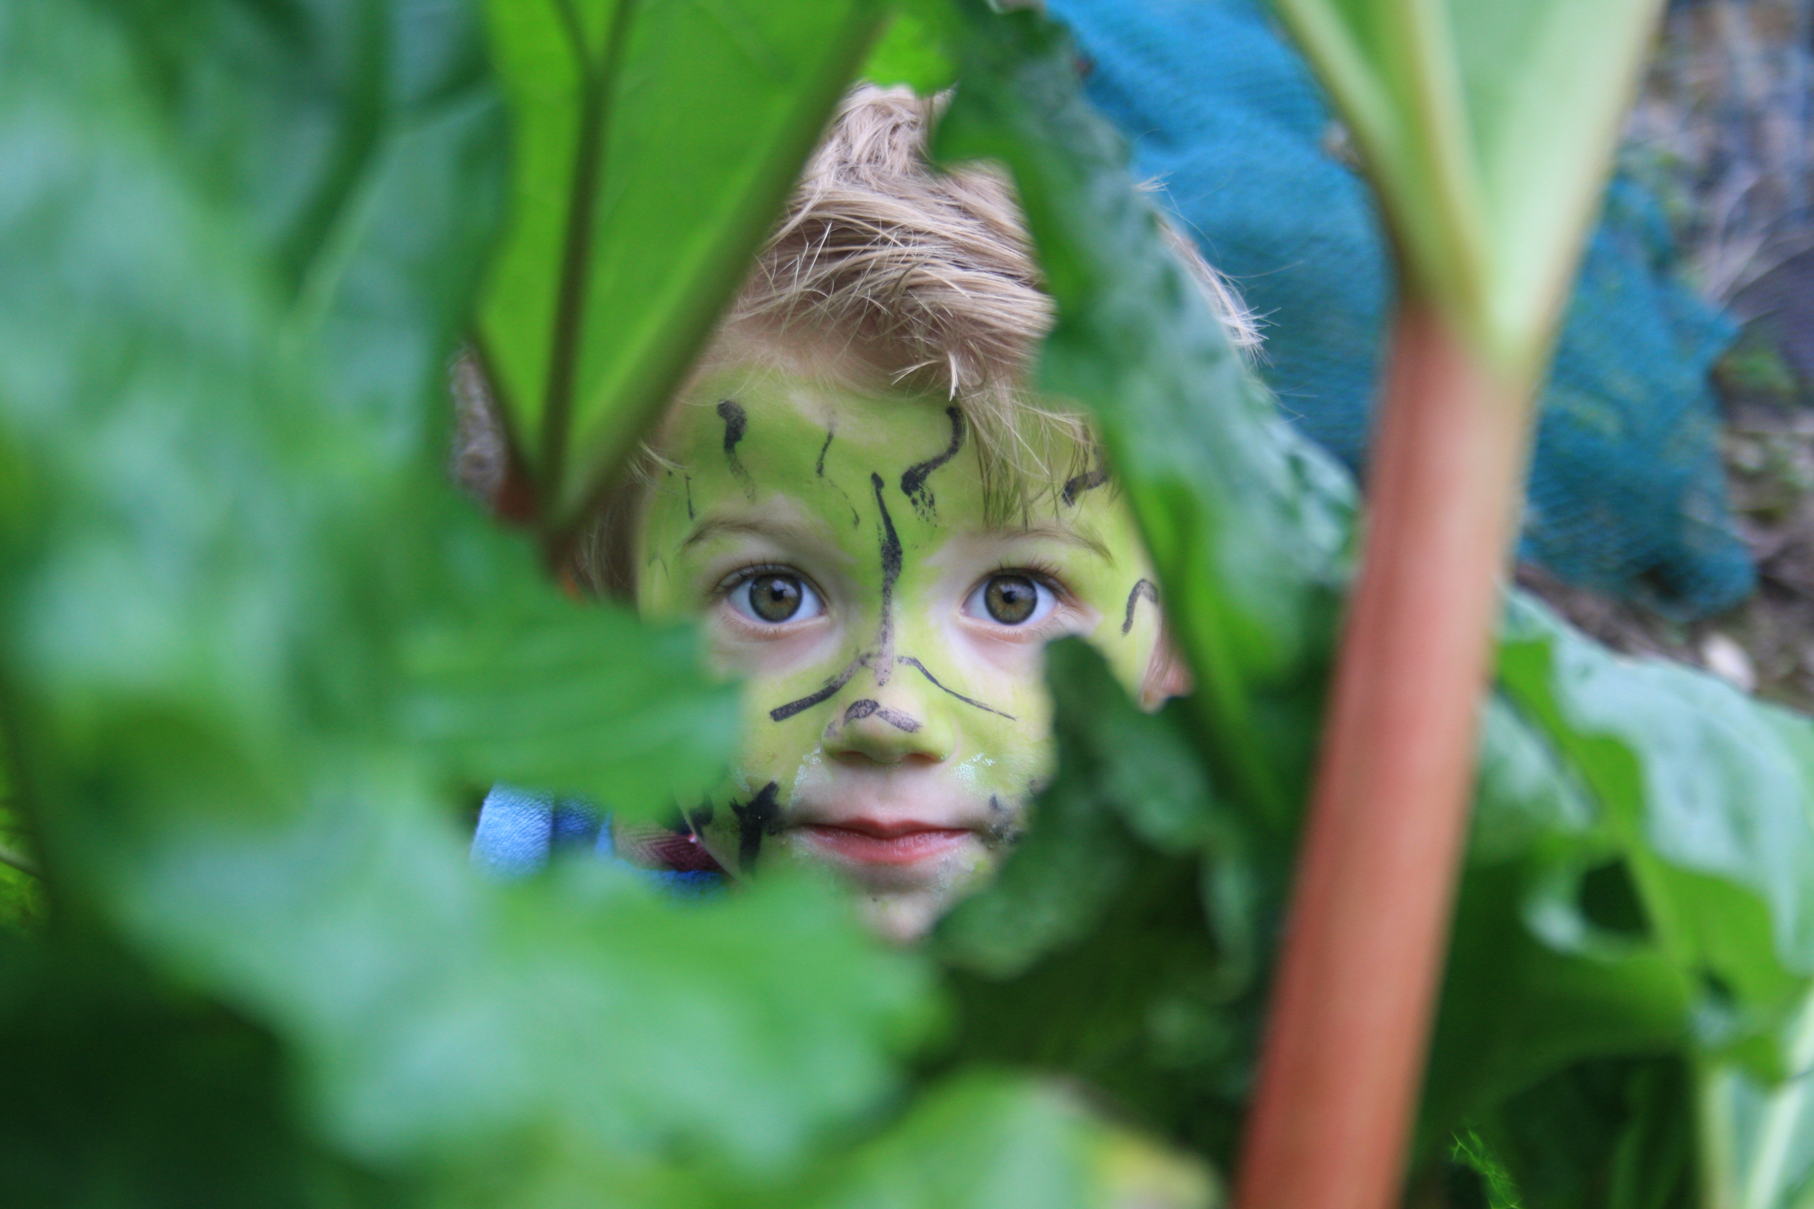

26, Eign Road Hereford HR1 2RY

[www.wyesidedaynursery.co.uk](http://www.wyesidedaynursery.co.uk)

wyesidenursery@gmail.com

01432 358070

**RE: September 2021 – EYFS Reforms - Observations, Assessment and Planning**

Dear Parents and Carers,

From September 2021, the Early Years Foundation Stage (EYFS) is changing. As part of these changes, we will be making some adjustments to the way we observe, assess and plan for your children.

**What is the EYFS?**

*The EYFS is the statutory Early Years curriculum. This is mandatory for all schools, settings and childminders to follow from birth up to the end of reception. The EYFS sets out our legal obligations regarding things like adult:child ratios, suitable people, safeguarding and welfare, staff qualifications, and learning and development.*

**What’s changing?**

* *Most of the changes are regarding Learning and Development, with some minor adjustments to Safeguarding and Welfare.*
* *Fundamentally, what we teach children is very similar, albeit worded differently.*
* *The new framework also specifically talks about the pressures of Early Years staff and wants to remove unnecessary paperwork requirements which result in time spent away from the children. It says the following: “Assessment should not entail prolonged breaks from interaction with children, nor require excessive paperwork. When assessing whether an individual child is at the expected level of development, practitioners should draw on their knowledge of the child and their own expert professional judgement and should not be required to prove this through collection of physical evidence.” – EYFS 2021*

**Changes to Safeguarding and Welfare**

* *The changes to Safeguarding and Welfare are largely wording based. For example “Local Safeguarding Children’s Board” has been changed to “Local Safeguarding Partners” to reflect some recent change in structure.*
* *A requirement for promoting the good oral health of children has been added.*
* *A specific requirement for promoting staff and children’s online safety has been added. This reflects the technological advances we have made since the EYFS was last reformed in 2012.*

**Changes to Learning and Development – Educational Programmes**

* *The Educational Programmes lead up to the Early Learning Goals – a description of what we want children to know by the end of Reception.*
* *These are divided in to 7 areas of learning. The ‘Prime’ areas form the basis for all learning, and the ‘Specific’ areas build on those skills and broaden children’s understanding, experiences and knowledge. In nursery, we always focus on the Prime areas in the first instance as they really do form the foundation for everything else.*
* *The 7 areas are divided down in to ‘aspects’ (like subheadings). The ‘aspects’ are changing as follows:*

|  |  |  |
| --- | --- | --- |
| ***Current EYFS (2012)*** |  | ***New EYFS (2021)*** |
| ***Prime Areas*** | ***Prime Areas*** |
| *Personal, Social, Emotional Development*   * *Making Relationships* * *Managing Feelings & Behaviour* * *Self Confidence & Self Awareness* |  | *Personal, Social, Emotional Development*   * *Self Regulation* * *Managing Self* * *Building Relationships* |
| *Communication and Language*   * *Listening and Attention* * *Understanding* * *Speaking* | *Communication and Language*   * *Listening, Attention and Understanding* * *Speaking* |
| *Physical Development*   * *Moving and Handling* * *Health and Self Care* | *Physical Development*   * *Gross Motor Skills* * *Fine Motor Skills* |
| ***Specific Areas*** |  | ***Specific Areas*** |
| *Literacy*   * *Reading* * *Writing* |  | *Literacy*   * *Comprehension* * *Word Reading* * *Writing* |
| *Mathematics*   * *Numbers* * *Shape, Space and Measure* | *Mathematics*   * *Number* * *Numerical Patterns* |
| *Understanding the World*   * *People and Communities* * *The World* * *Technology* | *Understanding the World*   * *Past and Present* * *People, Culture and Communities* * *The Natural World* |
| *Expressive Arts and Design*   * *Exploring and Using Media and Materials* * *Being Imaginative* | *Expressive Arts and Design*   * *Creating with Materials* * *Being Imaginative and Expressive* |

*Please be aware that these headings are those of the Early Learning Goals for the end of Reception. In nursery and pre school, we focus on learning the early skills that set children up to achieve these. For example, we build our gross and fine motor skills, mark making, excitement for learning, conversation skill, interest in books and print, strong sense of self and so on which eventually lead to mastery of reading, writing and all of the other fantastic things your child will learn as they grow and develop.   
  
All of the learning we do here, and most of the learning in reception is through quality, active play. “Teaching in the early years should not be taken to imply a “top down” or formal way of working. It is a broad term that covers the many different ways in which adults help young children learn. It includes their interactions with children during planned and child-initiated play and activities. communicating and modelling language, showing, explaining, demonstrating, exploring ideas, encouraging, questioning, recalling, providing a narrative for what they are doing, facilitating and setting challenges”- Ofsted.*

**What does all of this mean at Wyeside**

*“Assessment should not entail prolonged breaks from interaction with children, nor require excessive paperwork. When assessing whether an individual child is at the expected level of development, practitioners should draw on their knowledge of the child and their own expert professional judgement and should not be required to prove this through collection of physical evidence.” – EYFS 2021*

These changes and the removal of the requirement for a lot of evidence based tracking means that we are making some adjustments to the way we observe, assess and plan at wyeside.

The team here work hard to ensure they know your children extremely well, we observe their play, development and interests, we assess what they know and what we want them to learn and then we plan activities and provision which will extend their development and teach them something new or help to bed in the skill they are already mastering. All of these things are done by using our understanding of child development and our knowledge of your child as an individual person.

At the moment, we produce written observations which are sent to you through tapestry and are designed to help us ‘track’ the children’s learning and development. These observations are time consuming and require staff to spend time away from doing what they do best every day. Up until now it has been a requirement for us to produce evidence based tracking. Now this requirement has been removed, we have decided to use our Practitioners’ time more effectively.

We still want to keep parents up to date with their children’s learning and development, and give you snapshots of their nursery day, so we plan to offer the following from the end of the Summer Term.

* We will continue to upload photos to tapestry. These will be a mixture of group and individual updates.
* Each half term (approximately 6 weeks), we will send you a development summary for your child. This will tell you what we have been learning, what we’ve been enjoying, talk about their wellbeing and whether their development is as expected or if there is anything we need to work on. We plan to continue to do this through Tapestry. There are a number of non statutory guidance documents to help with this, we will choose the correct one for our setting over the summer and may use additional documents if they are of benefit to your child, such as if they have additional needs or are learning English as an additional language.
* We will continue to complete the 2 Year Progress Check. This is a statutory progress check to be completed between 24 and 35 months. Due to the impact of the pandemic, the government disapplied it for quite some time but it is now back in effect.
* When your child moves from one room to another, we will complete an ‘All About Me Now’ in conjunction with you to allow fully up to date information about your child to pass between key people.
* When your child goes to school, we will continue to produce Transition Documents to support this.

Should you have any questions, concerns or queries, please don’t hesitate to contact me by email, Tapestry message or phone.

Yours sincerely,

Niki Pearce

Early Years EYFS and Curriculum Development Lead